**Spark installation**

**Install Anaconda from official site :**

- Go to: <https://www.anaconda.com/products/distribution>

-Install according to your OS and window.

**Install Java in Oracle website:**

-**Java 11, Java 17** can download we can work on this both version.

-Install on your window and run it.

Install Apache spark:

- Download Spark 3.5.x pre-built with Hadoop.

-Go to: <https://spark.apache.org/downloads.html>

-It will download as zip file and exact the zip file to c drive.

-Rename the folder name as **spark .**

Install winutils :

-Download winutils from **github 3.3.6 version.**

-Go to : <https://github.com/cdarlint/winutils>

-Create a folder **Hadoop** in c drive inside the folder create another folder of **bin** and paste the winutils inside the bin folder .

-Paste the winutils inside **spark ->bin->paste it .**

Install MySql workbench :

- Download from: dev.mysql.com

-Run the workbench with root

-Refer the steps in youtube : <https://youtu.be/hiS_mWZmmI0?si=aD2jFIHvsHhwPl5F>

Because of missing some steps the we cannot work in MySql.

Install MySql connector :

- Use MySQL Installer from dev.mysql.com

-Downloaded as zip file and extract the file.

-Inside it **jar file** will be there ,copy the jar file and and paste it in **jar folder** inside the **spark folder.**

Path setting :

-Go to environmental variable and in system variable click path->edit->new.

-paste path of **spark ,java ,Mysql workbench and hadoop** with bin in it.

-paste these all in path

%JAVA_HOME%\bin

%SPARK_HOME%\bin

%SPARK_HOME%\sbin

%HADOOP_HOME%\bin

-In system variable create new variables with path

JAVA_HOME with path without bin

SPARK_HOME with path without bin

HADOOP_HOME with path without bin

Checking :

-Open your cmd and command this to verify whether your path are set and installed properly.

-For Java:

Cmd : **java -version**

Output:

Coorect : java version "17.0.2" 2022-01-18 LTS

Java(TM) SE Runtime Environment (build 17.0.2+8-LTS-86)

Java HotSpot(TM) 64-Bit Server VM (build 17.0.2+8-LTS-86, mixed mode)

Wrong : 'java' is not recognized as an internal or external command, operable program or batch file.

-For Sql:

Cmd : **mysql --version**

Output:

Coorect mysql Ver 8.0.35 for Win64 on x86_64 (MySQL Community Server - GPL)

Wrong : 'mysql' is not recognized as an internal or external command, operable program or batch file.

-spark:

Cmd : **spark-shell**

Output:

Coorect :

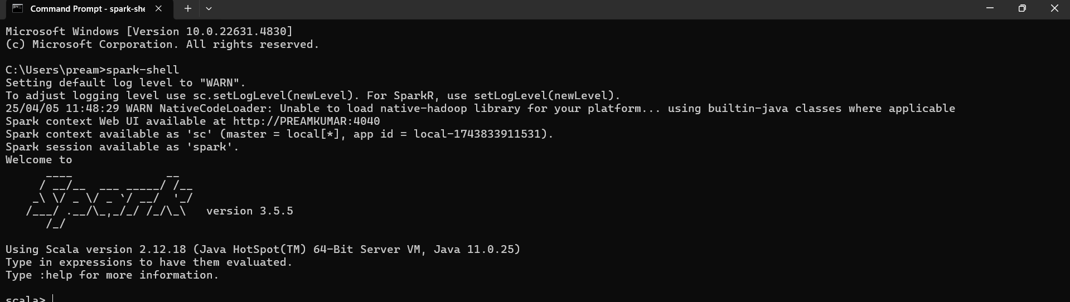Wrong : 'spark-shell' is not recognized as an internal or external command, operable program or batch file.